AA Enterprise Framework

**Faster development** and **robust automation** made possible by the following features:

1. Modular template for easy automation of complex use cases.
2. Access to key-values from a configuration excel file which can be easily maintained and altered to suit business cases.
3. Efficient error handling techniques used with configurable auto-recovery mechanisms.

Developer guide for using AA Enterprise Framework

1. Deploy framework in the respective folders in the Automation Anywhere Application path. This can be done by downloading from control room or by backend migration (extract and copy-paste files attached below). Do retain the folder structure.



1. Populate/Add the necessary key-values in the Config.xlsx file.
   1. Do not remove the key ***MaxRetryCount*** from the config (or else please make the necessary changes in the code). It may be configured to a different value if required.
2. Open the workflow file ***EnterpriseFramework***for edit in Automation Anywhere Client.
3. Open the task ***Initialize***and do the following:
   1. Add any new variable initializations that are required.
   2. Kill/Close all applications used in the automation use case.
      1. For this, Open the task ***CloseAllApplications*** and add the commands to close the relevant applications. ***CloseAllApplications***is also executed at the end when the bot completes automation.
   3. Open all applications used in the automation use case.
      1. For this, Open the task ***OpenAllApplications*** and add the commands to open the relevant applications.
4. Open the task ***GetTransaction*** and do the following:
   1. Add business logic to get transaction item based on transaction id (or any other logic applicable) and assign result to *vOutTransactionItem*.
5. Open the task ***ProcessTransaction*** and do the following:
   1. Add business logic that is to be applied to the transaction item retrieved in step #5.
6. The task ***UpdateTransactionId*** will automatically run to iterate to the next transaction.
7. The task ***SetRetryCount*** will automatically initiate recovery mechanism.

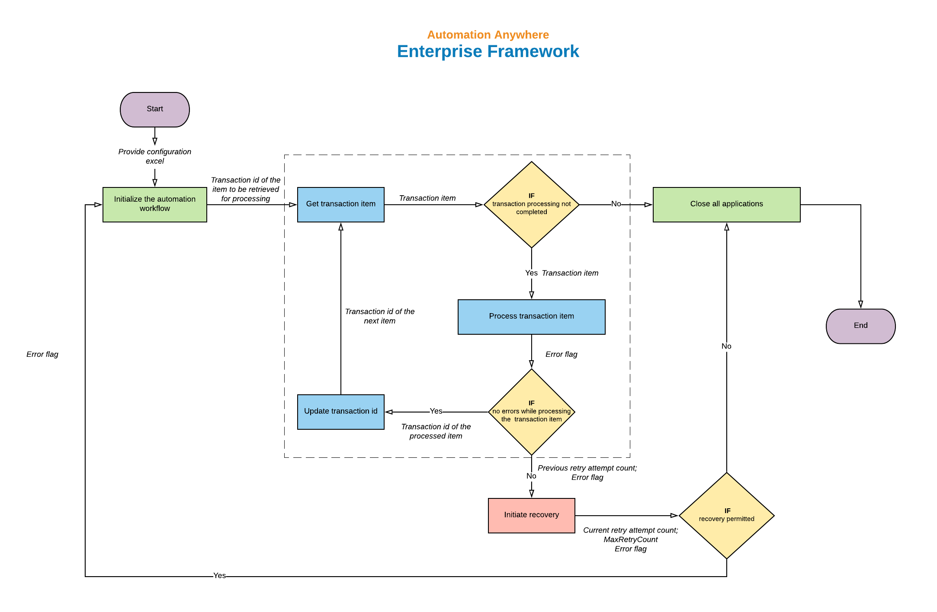

Specification of the Taskbots used:

|  |  |  |  |
| --- | --- | --- | --- |
| Name | Description | Input | Output |
| Initialize | Prepare XML config for further use; Initialize TransactionId value; Close/Kill relevant apps; Open relevant apps | * vInIsError: True/False based on any error that has occured in ProcessTransaction. Default value is False * vInRetryNumber: Current count of retry attempt if it is a retry attempt. | * vOutConfigXML: Config values as XML string * vOutMaxRetryCount: Value MaxRetryCount read from config * vOutTransactionId: Value of transaction id initialized during first attempt |
| CloseAllApplications | Close relevant applications if open | None | None |
| OpenAllApplications | Open relevant applications: called from within Initialize | None | None |
| ExcelToXML | Convert Excel data in Key value pattern to XML data with Key as nodes and Value as node values | * vInExcelPath: Provide path of the excel to be converted to XML * vInOutputXMLFileLocation: Provide desired path of the xml output file * vInLogLocation: Provide desired path of the log file of the ExcelToXML bot * vInBuildXMLSheetWise: Provide True for building XML nodes categorized based on sheets in the excel file | * vOutXML: Get the newly created XML as string in this variable. The XML file will also be saved in vInOutputXMLFileLocation |
| GetTransaction | Retrieve transaction item | * vInTransactionId:Transaction id of the transaction item to be retrieved * vInConfigXML: XML Config string | * vOutTransactionItem: Transaction item corresponding to the transaction id. This item is passed to Process transaction for further processing. * vOutTransactionStatus: Stores the status of the transaction. Will be 'In Progress' by default. Value will be changed to 'Completed' upon processing of all transaction items. |
| ProcessTransaction | Perform necessary actions with the transaction item retrieved in GetTransaction | * vInTransactionItem:Transaction item to be processed * vInConfigXML: XML Config string | * vOutErrorInProcessTransaction: Set to True if error occurs in ProcessTransaction and recovery mechanism is initiated |
| UpdateTransactionId | Increment transaction id to repeat automation for the next transaction item | * vTransactionId:Transaction id of the transaction item processed by Process transaction | * vTransactionId:Transaction id of the transaction item to be retrieved next |
| SetRetryCount | Set number of current retry attempt | * vLastRetryNumber: Number of last retry attempt | * vRetryNumber: Number of new retry attempt * vLastRetryNumber: Updated number of last retry attempt |